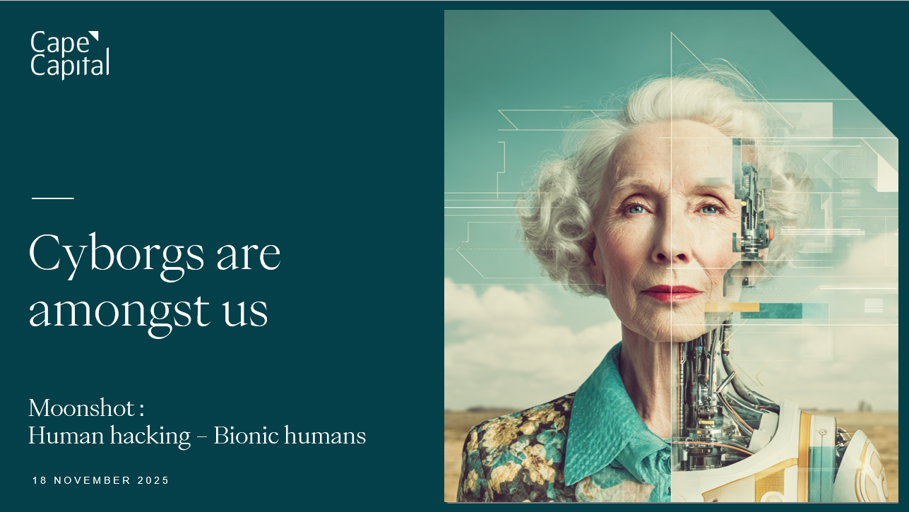
Bionic Humans – Summary
Presentation has been added to the usual folder (pdf) and to the Moonshot folder (ppt).
- Bionic humans represent the convergence of biology and technology to augment, restore, or enhance human physical capabilities—sometimes beyond natural limitations.
- Market driver: demographic urgency. Global population aged 65+ will reach 1.6 billion by 2050 (1.16 billion by 2035). Regulatory approval is the key unlocking mechanism—Medicare's April 2024 exoskeleton coverage decision unlocks a USD 30 billion market, transitioning bionic humans from science fiction to health insurance.
- Market forecasts: 50 million people will use bionic augmentation daily by 2033. Artificial blood market alone valued at USD 11.7 million in 2025, projected to grow at 20.5% CAGR to USD 62.5 million by 2034; broader blood substitutes market forecast USD 3.7–3.8 billion (2024) to USD 8.7 billion by 2035.
- Technology moats eroding. Brain-nerve interfaces now enable direct prosthetic control with artificial sensory feedback (Boston, 2025). Bionic devices exceed biological performance—Össur Flex-Run prosthetic generates 30% more energy return than natural ankles, enabling Paralympic sprinters to challenge Olympic qualifying times.
- Sensory augmentation advancing rapidly. Retinal implants stimulate neural circuits; bionic eyes detect wavelengths invisible to human biology. AI-powered hearing technologies suppress background noise, solving cochlear implant users' primary complaint. ETH Zurich's soft robotics lab now grows prosthetics rather than manufacturing them—biohybrid actuators heal rather than break.
- Industrial & military applications reshaping labour. German Bionic exosuits support 38 kg per lift; military-grade versions alleviate 70% of carry load. Manual work becoming easier, healthier, safer—capacity-expansion play for high-risk, physically demanding sectors.
- Adoption curve: therapeutic shifting to elective. Current users 95% injury/disability-driven; by 2030, 25–30% adoption forecasted for performance enhancement in sports, military, industrial contexts. Emerging debates: therapeutic vs. enhancement boundaries, insurance coverage for elective augmentation, workplace fairness (augmented vs. non-augmented workers).
- Regulatory competitive moat. International Paralympic Committee (IPC) enforces equipment safety and commercial availability standards. Regulatory approval and reimbursement decisions—not technological capability—unlock scale.
- Investment implications: regulatory access & consumer adoption are the critical gates. Current investable universe concentrated in medical device incumbents; venture activity in soft robotics, neural interfaces, and artificial blood substitutes represents frontier of value creation.
Ranking: 36/48
Score: 52

